1. Insert new records into the table

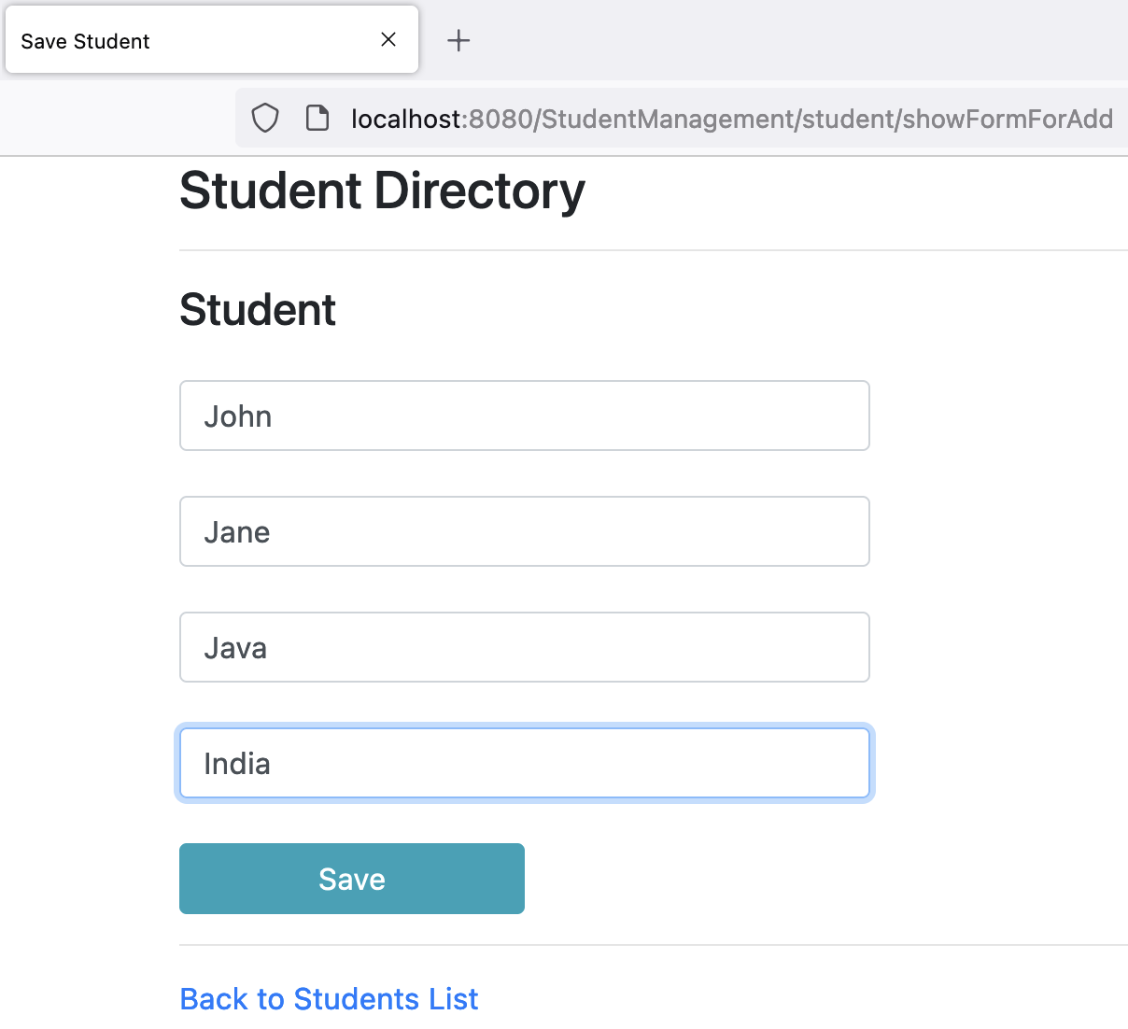

Saved successfully:

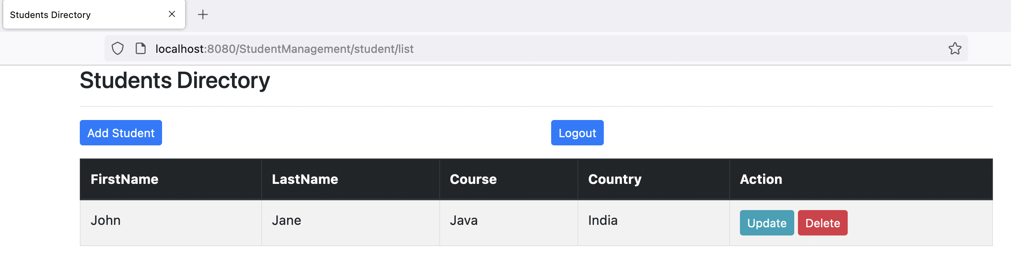

Saved in database:

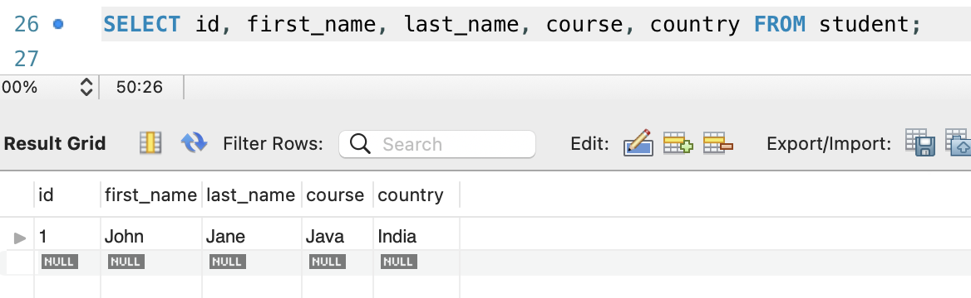

Added a few more students as shown below:

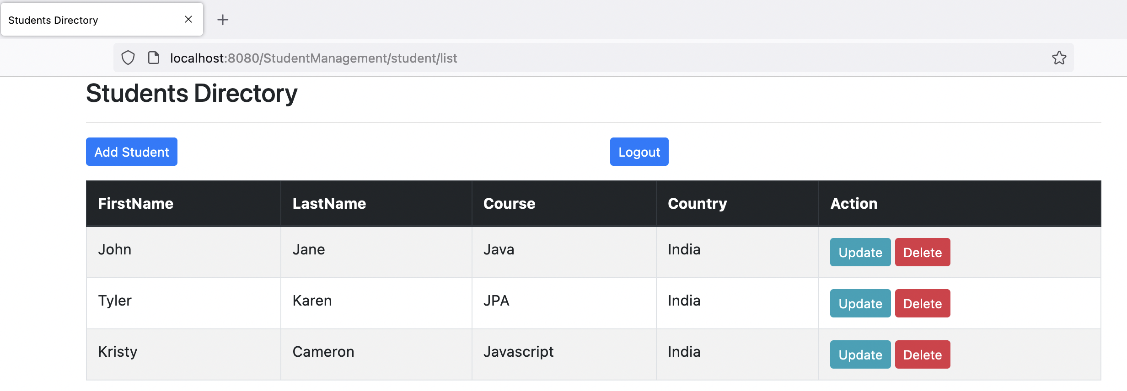

1. Update existing records into the table.

John details before update

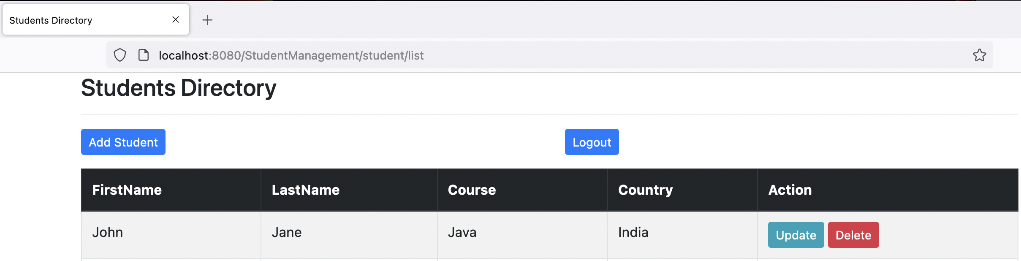

Updating as below:

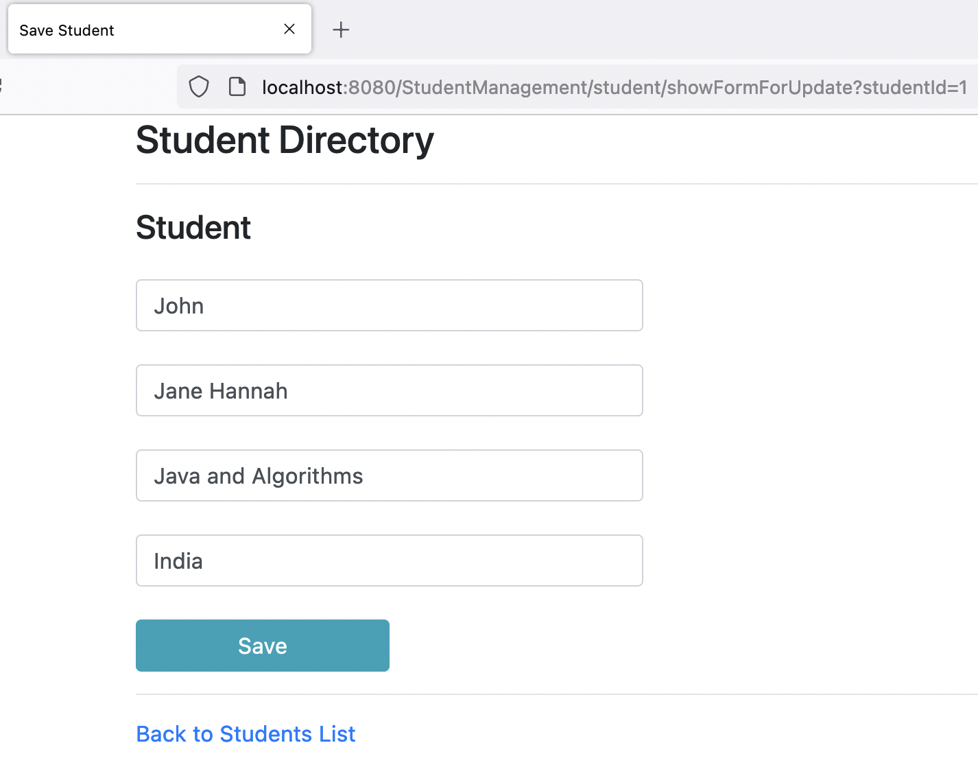

After Update:

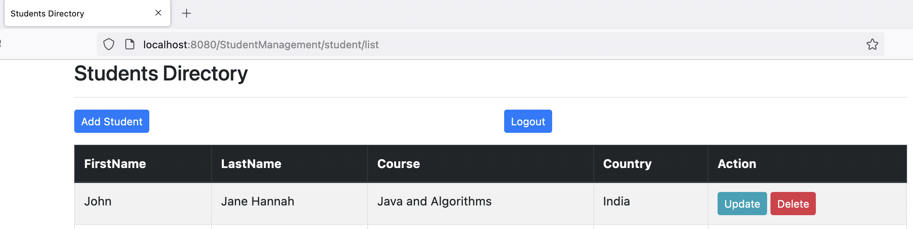

Updated in the database:

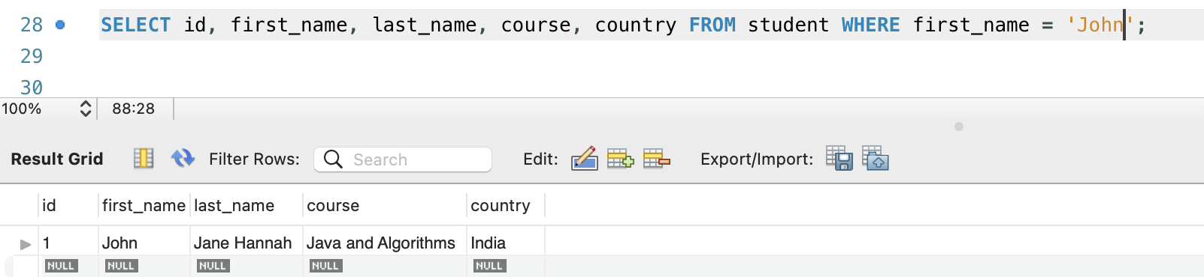

1. Delete existing records from the table.

Deleting Kristy. Below is the before delete:

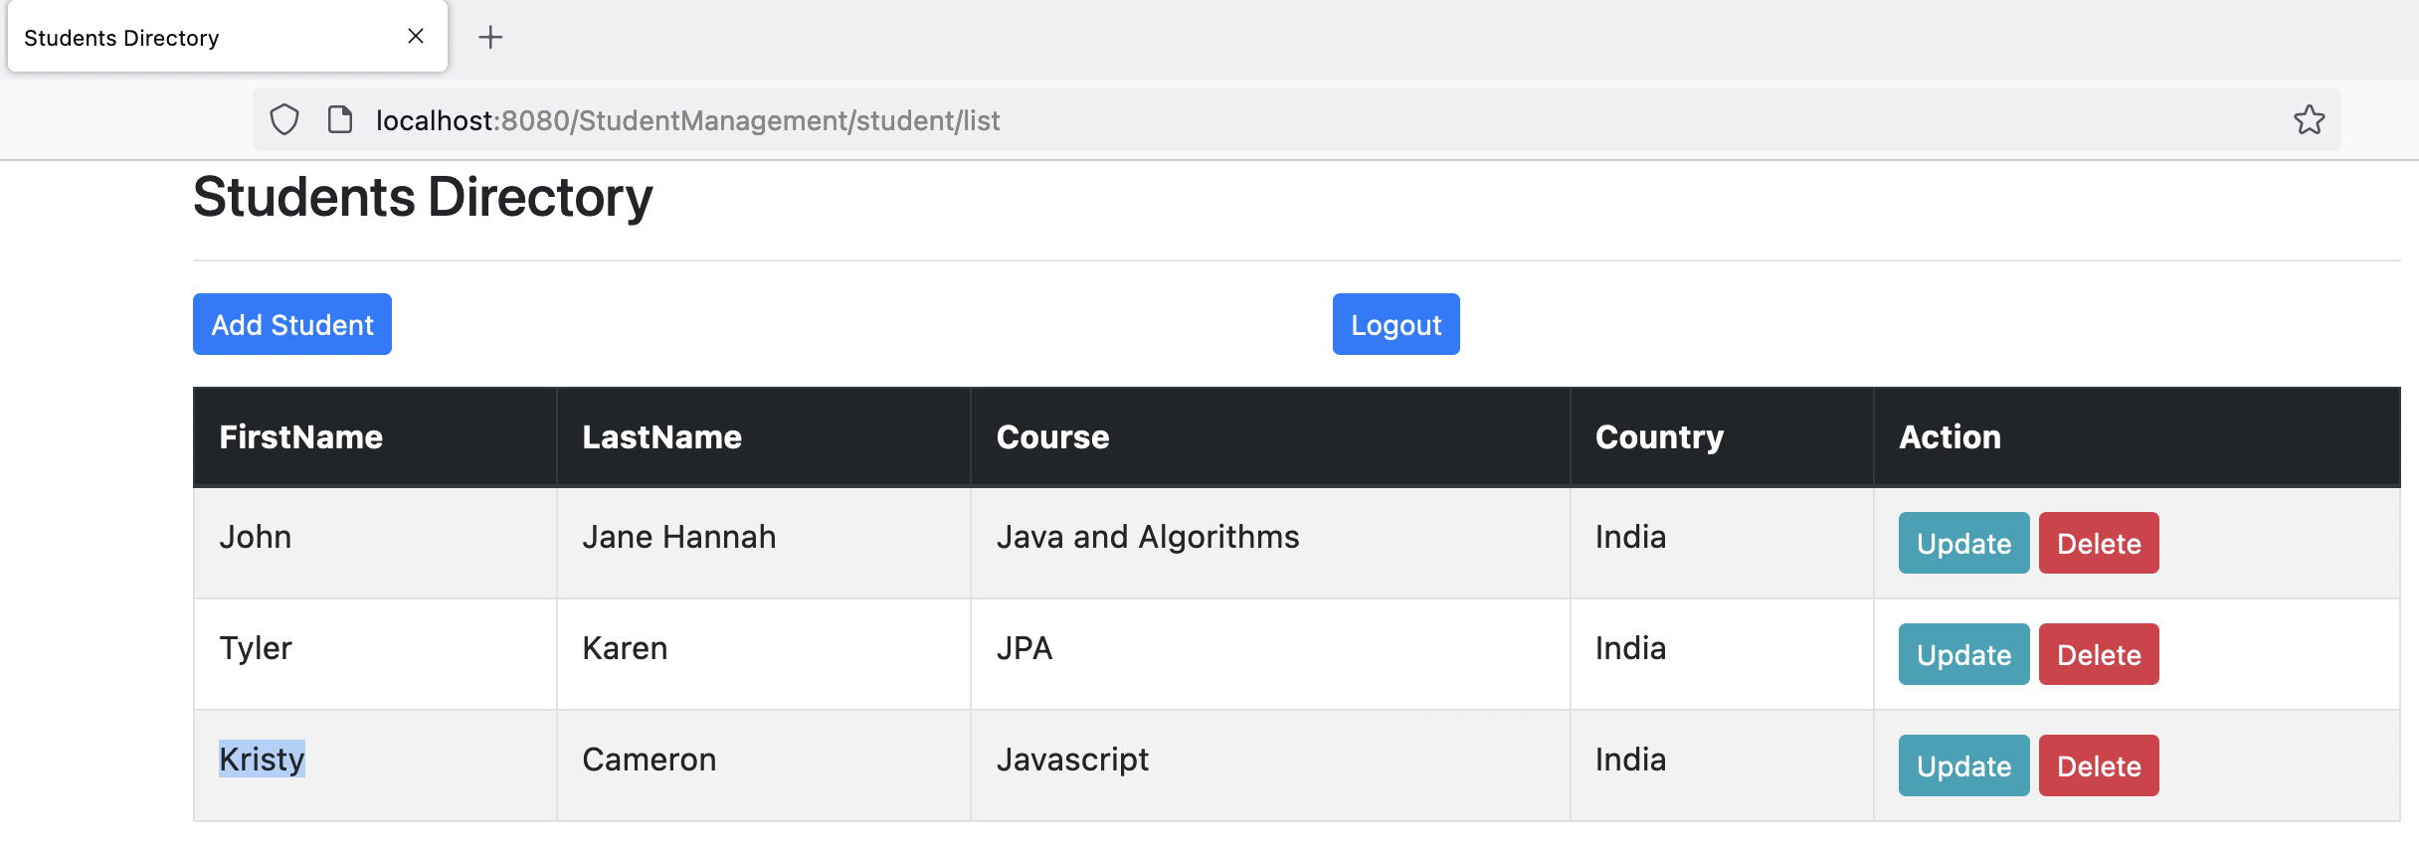

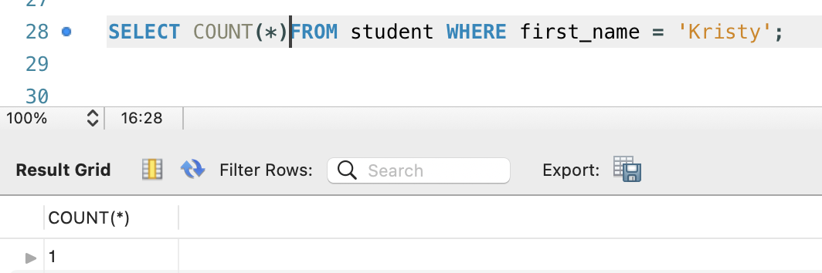

After delete:

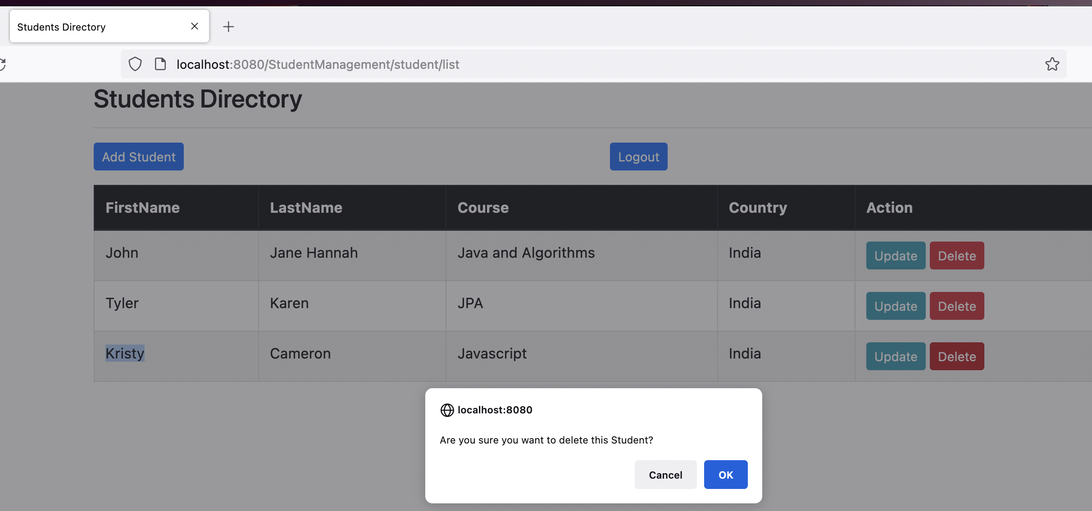

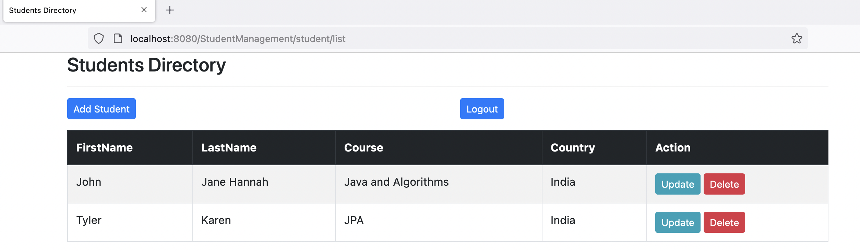

Deleted in the database:

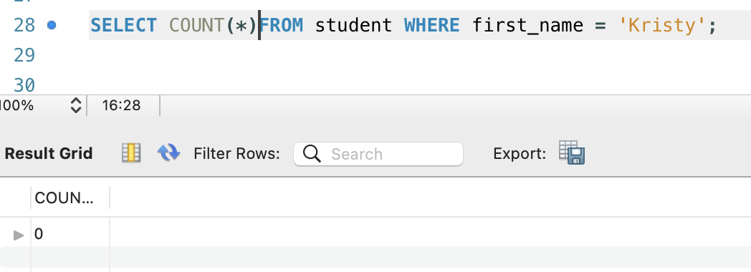

1. Print all records from the table.

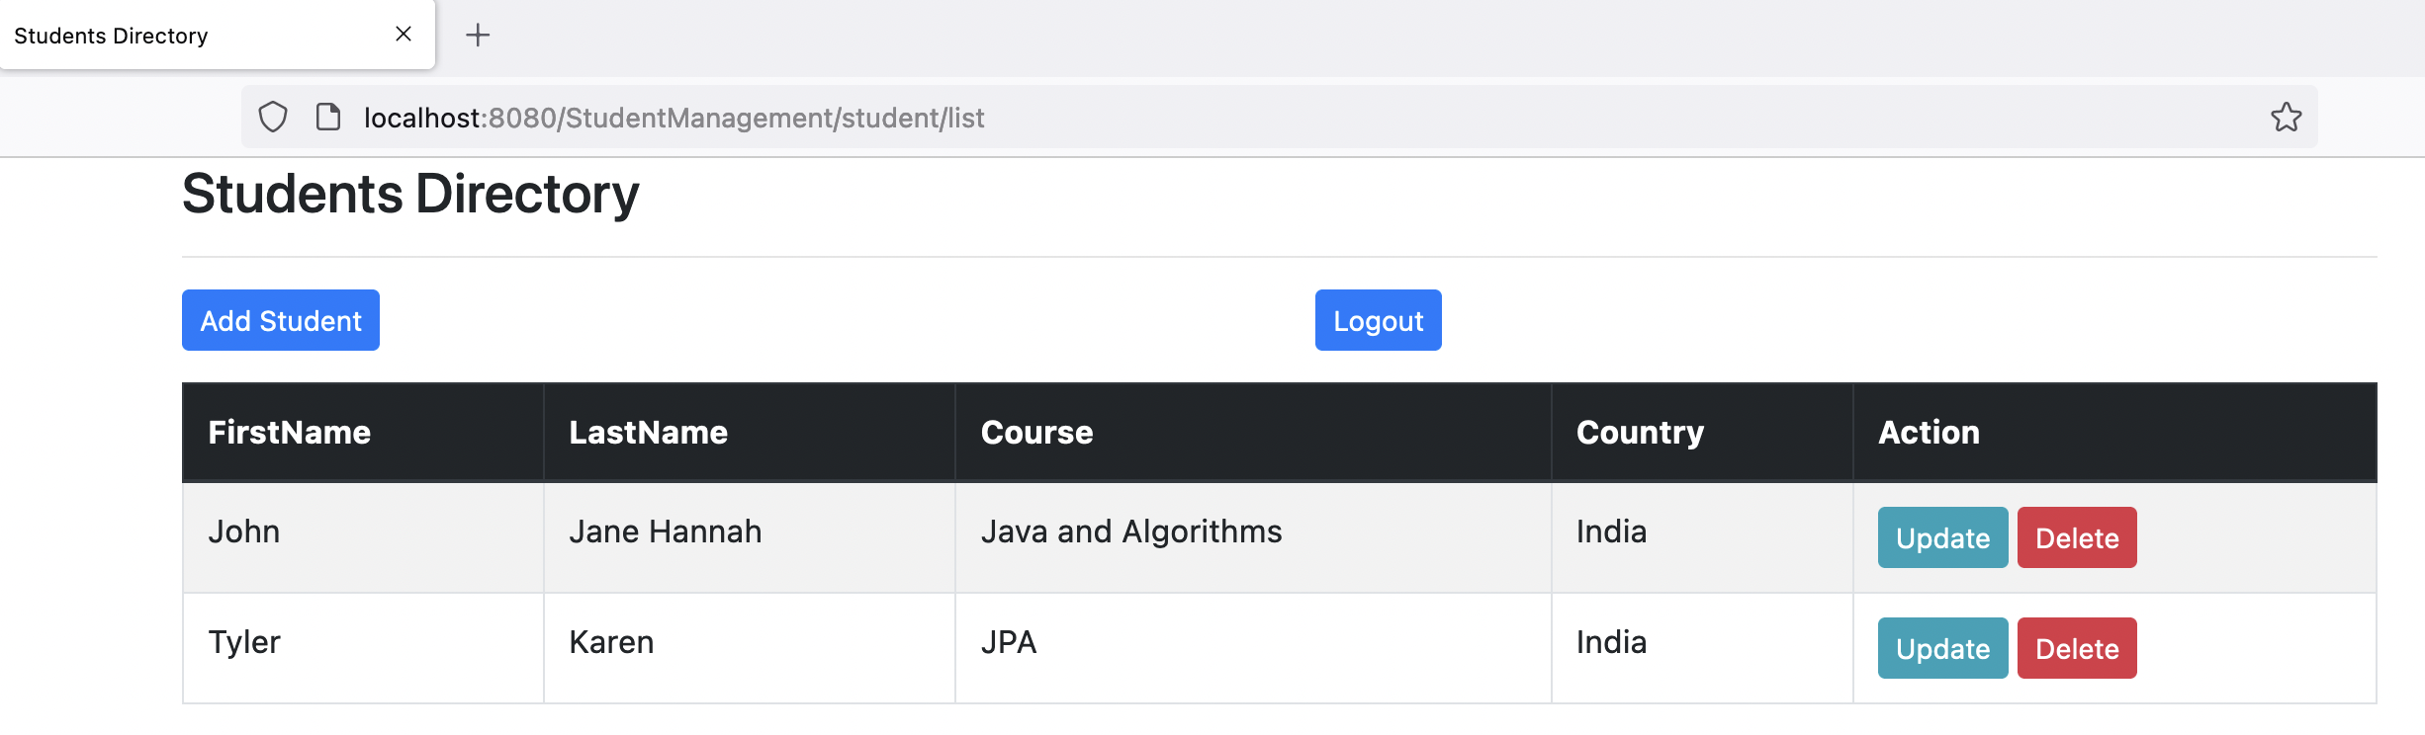

Database table:

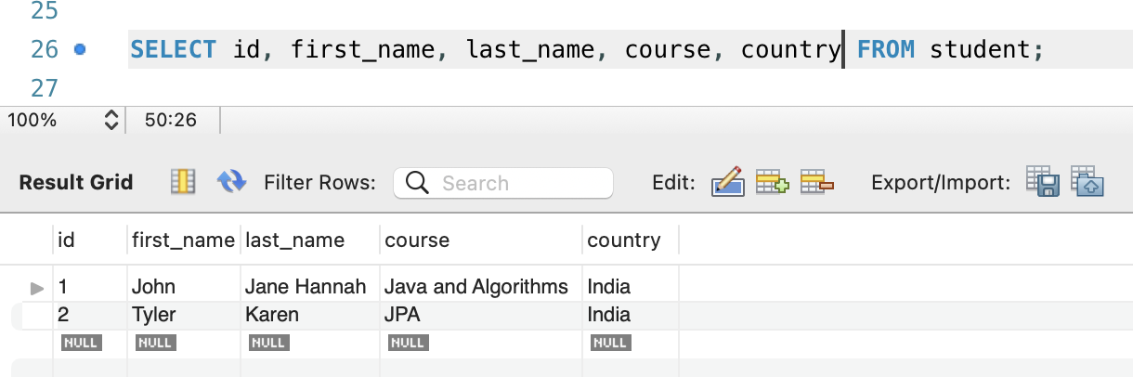

1. Add a security layer where there will be two roles USER, ADMIN.

After adding the security layer browser shows sign in as below when trying to access the API

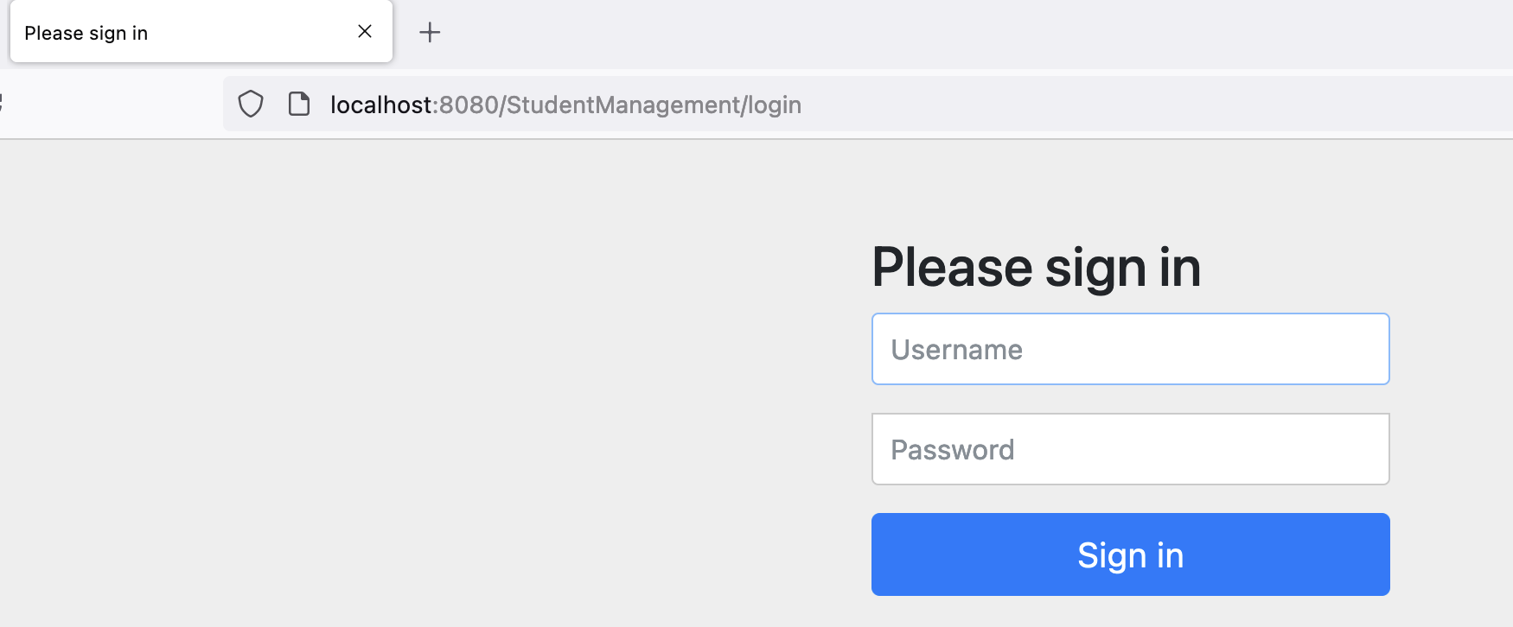

Below are the details of Users and roles in the database:

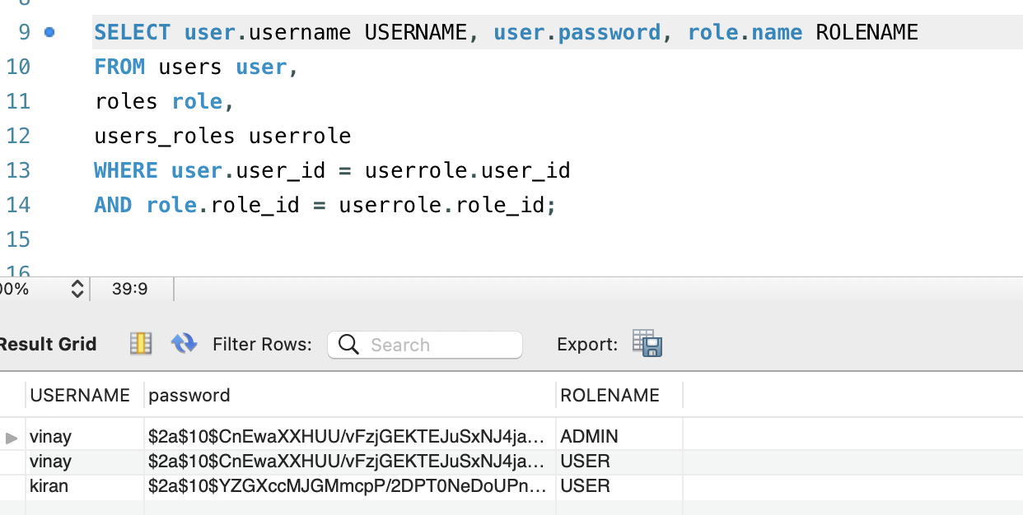

1. Admin will have the privilege of performing all the operations.

User vinay has ADMIN role as shown in the above database screenshot.

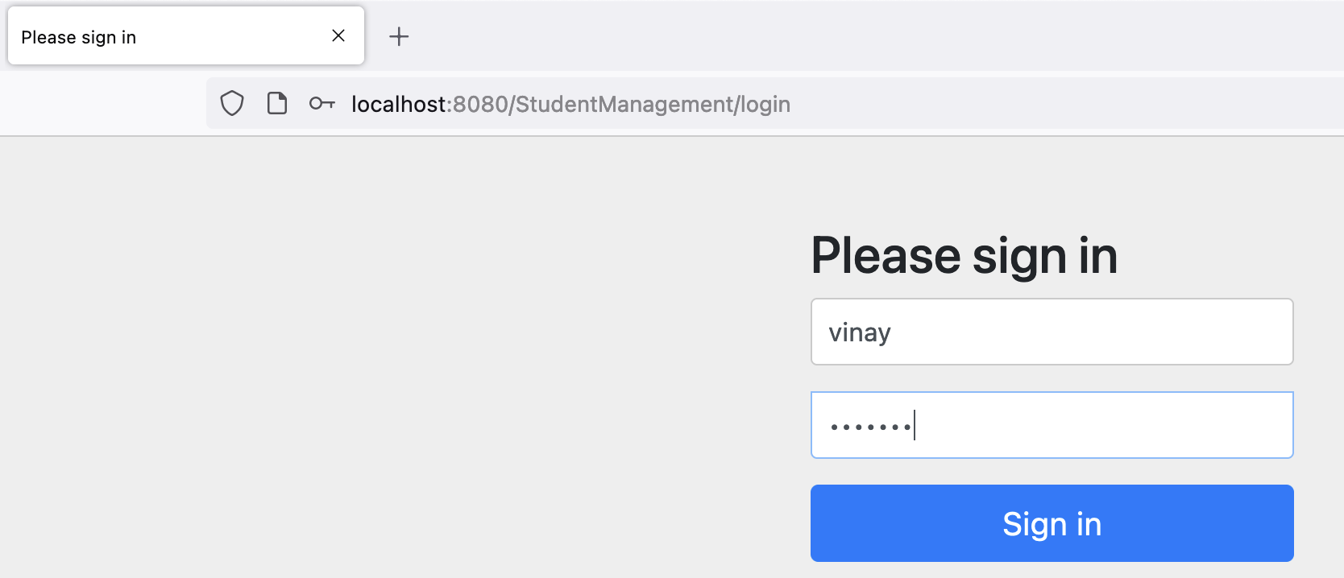

Insert operation:

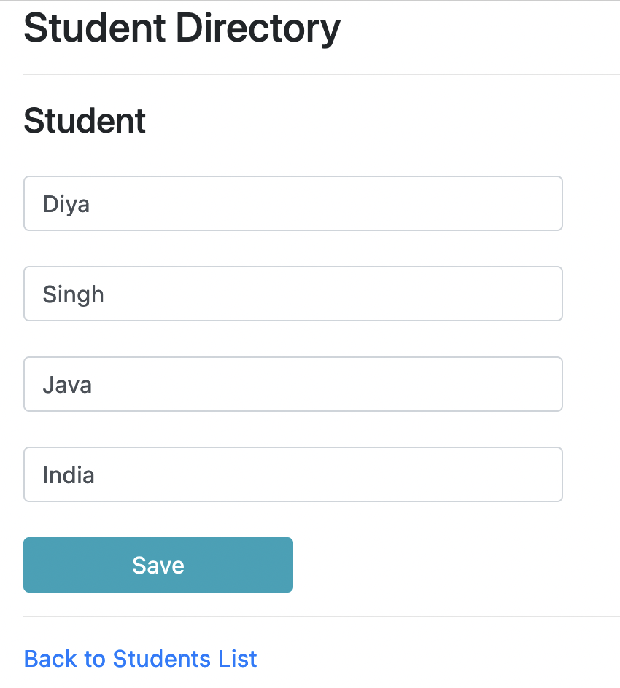

Saved Successfully

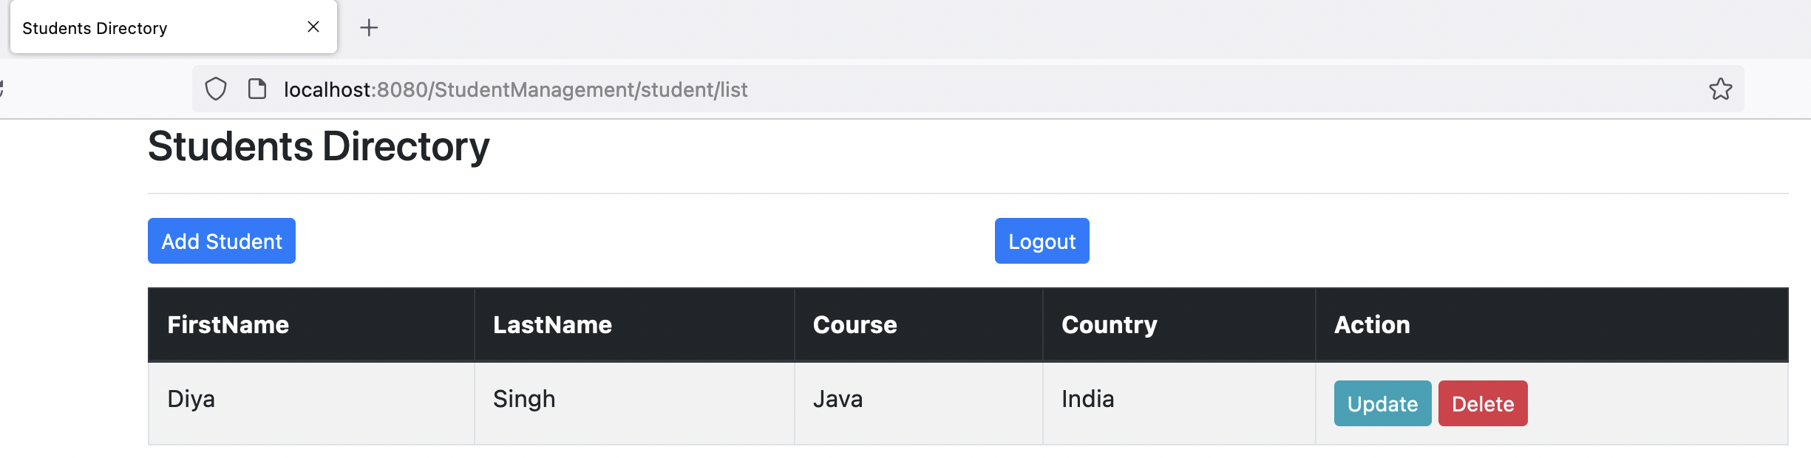

Inserted one more student:

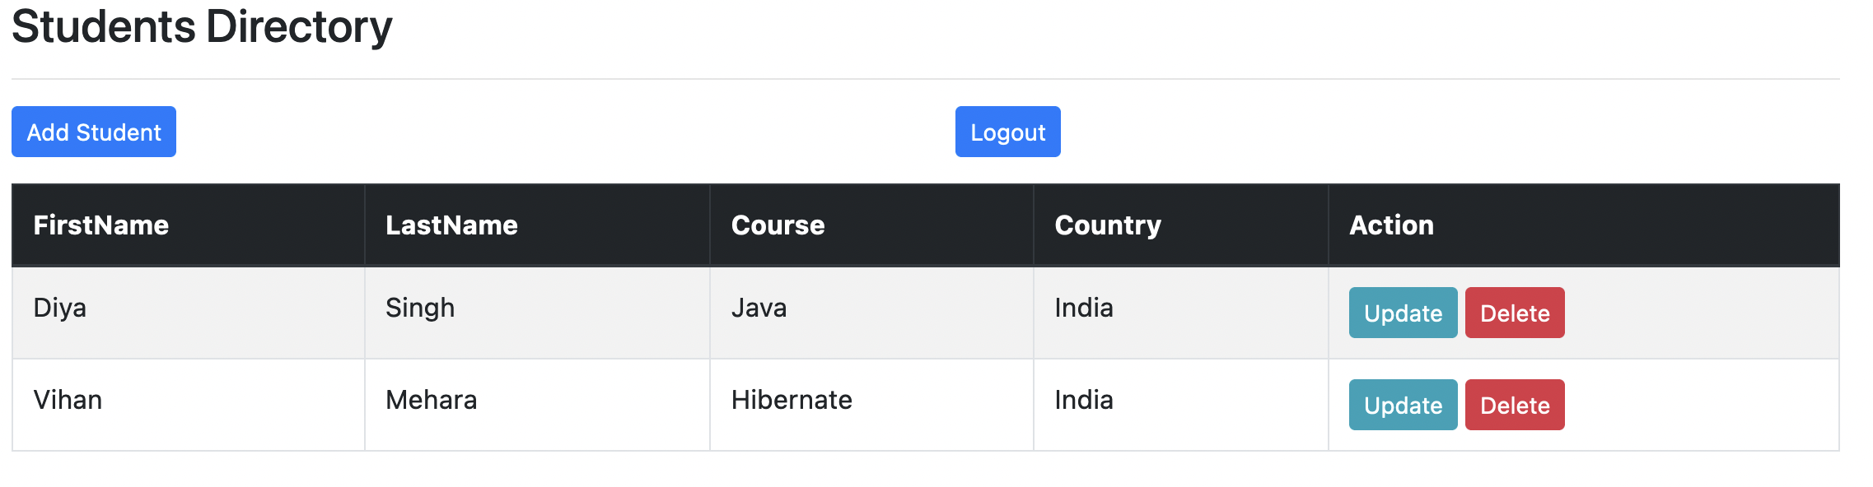

Data in the database:

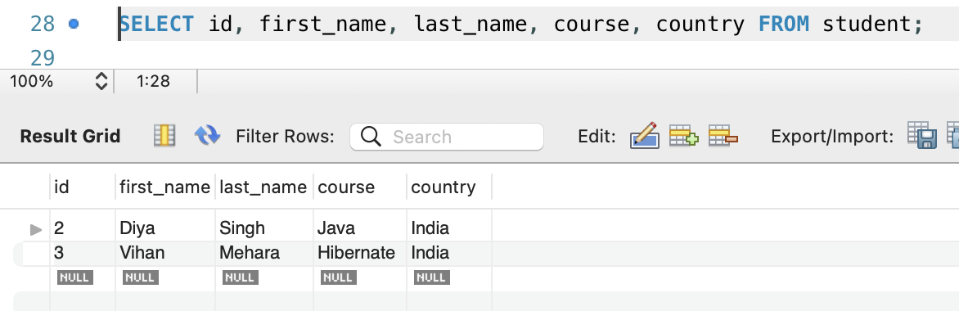

Update Operation:

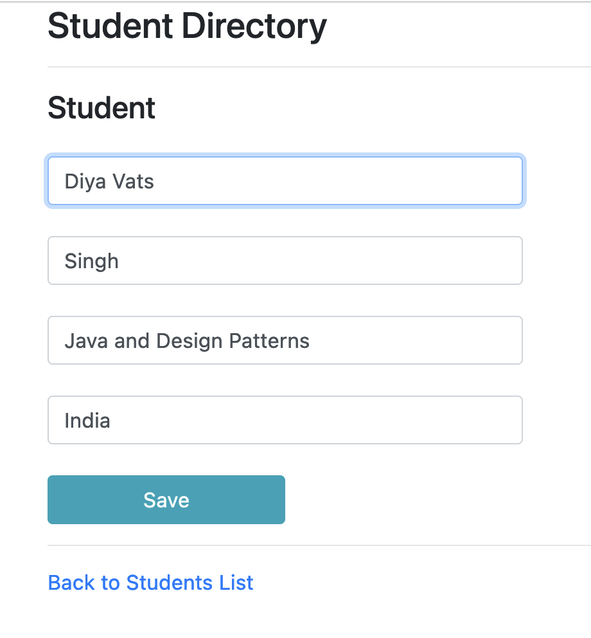

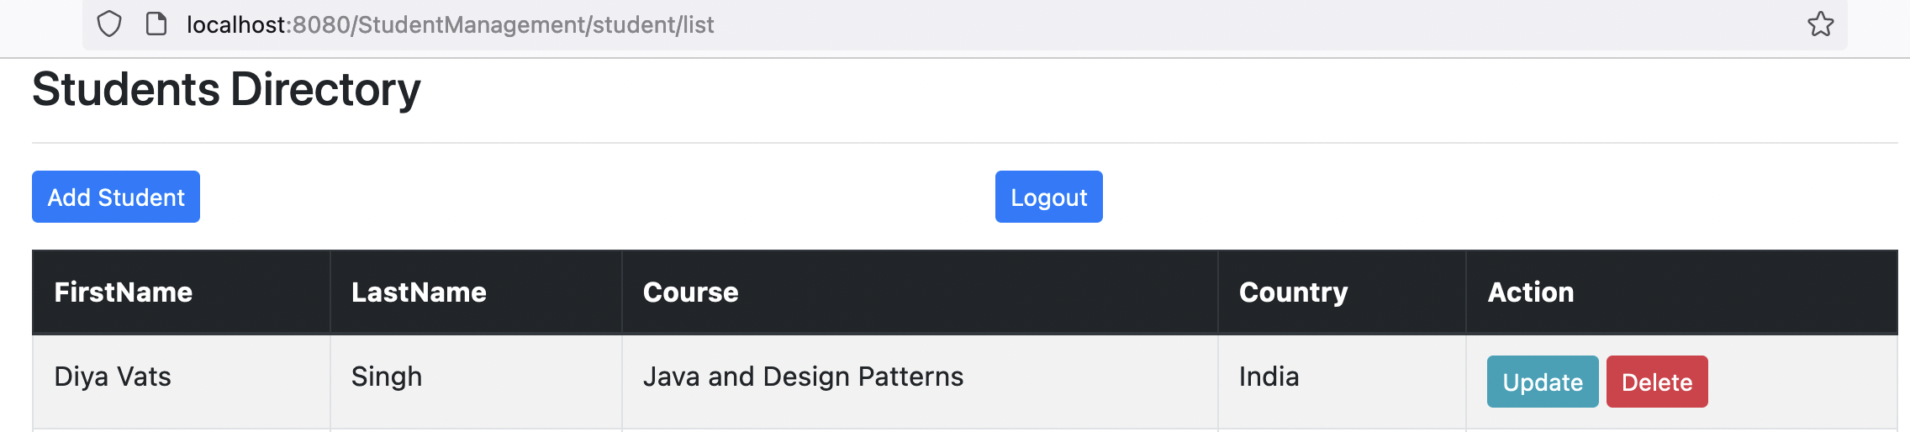

Data in the database:

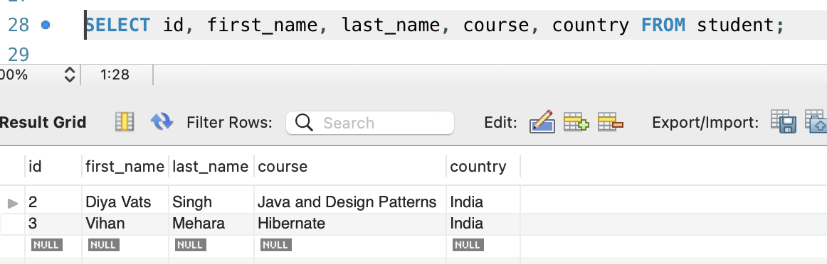

Delete Operation

Deleting vihan

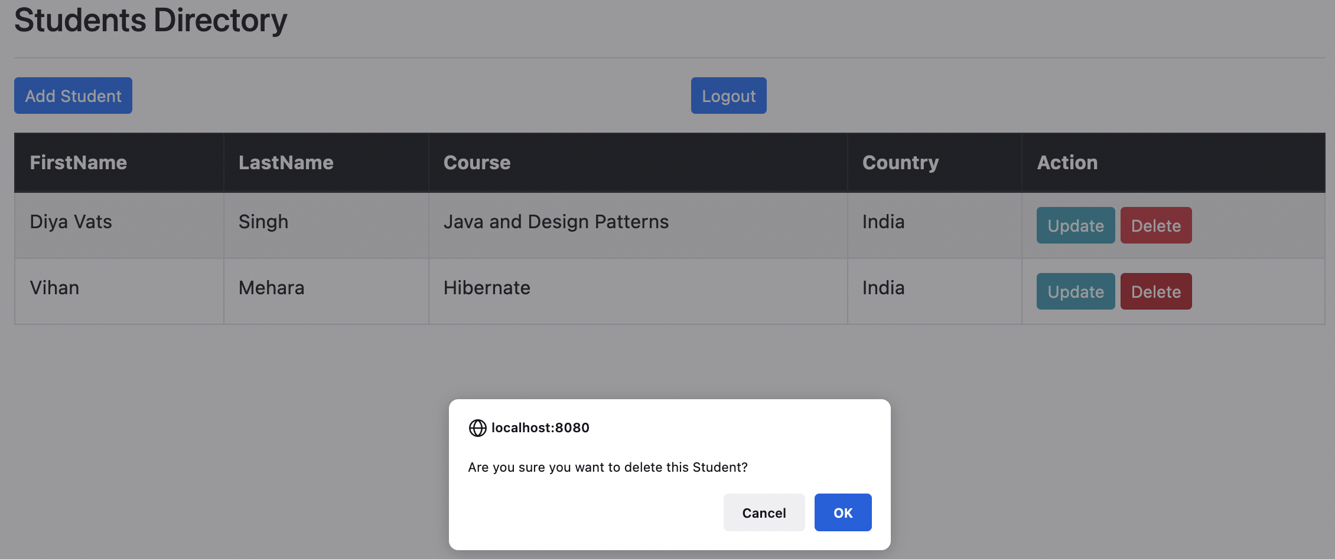

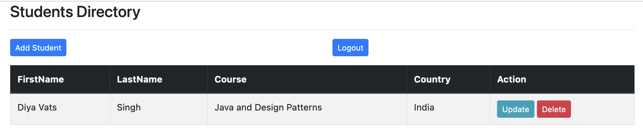

Data in the database:

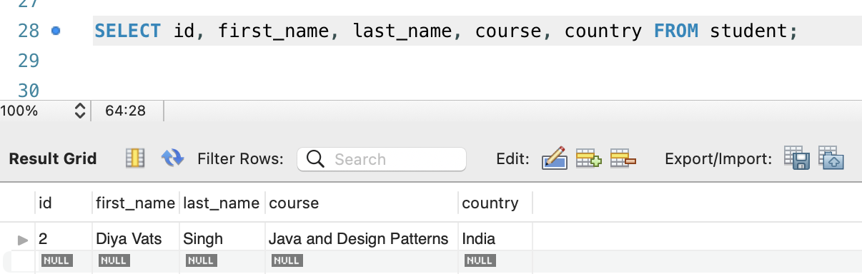

1. User can view the details

User kiran has USER role

Below are the details of Users and roles in the database:



Login using kiran user as shown below

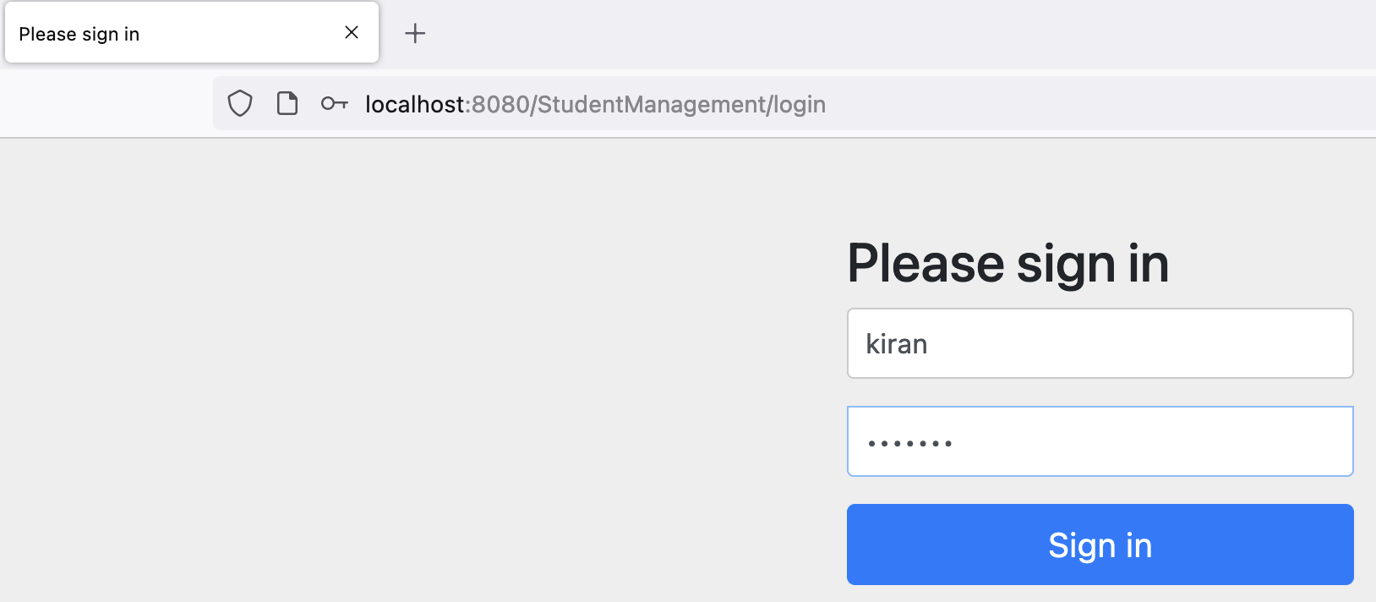

User is able to view the student data

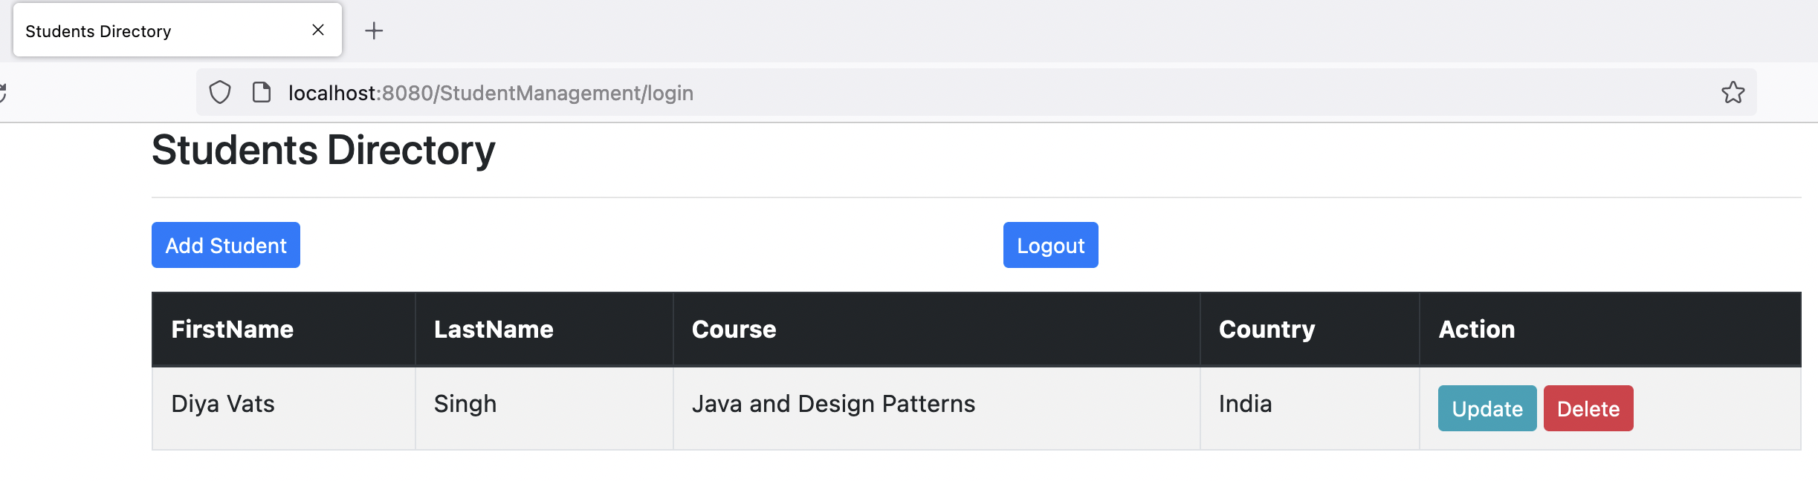

Trying to add a new Student

As user has no ADMIN role, API does not allow to perform any insert, update and delete operations.

Insert Student operation is unsuccessful due to role privilege as shown below.

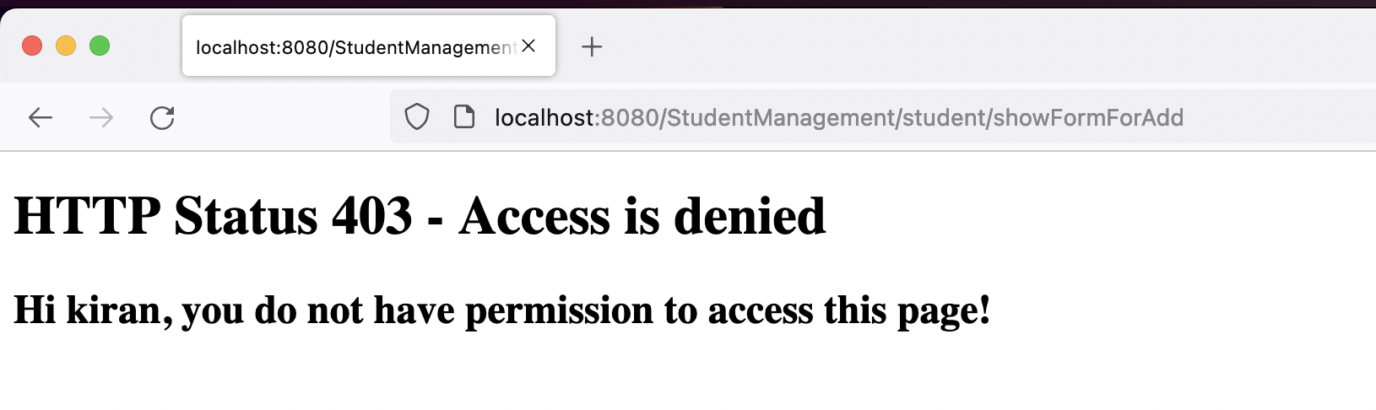

Update Student operation is unsuccessful due to role privilege as shown below.

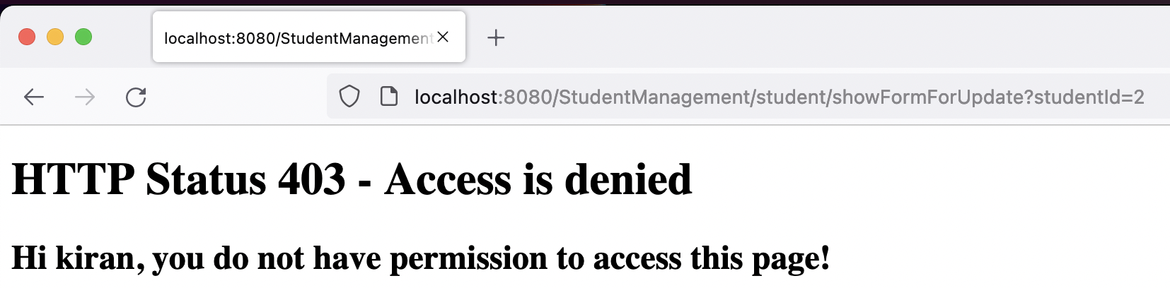

delete Student operation is unsuccessful due to role privilege as shown below.

